Creating your Acrobat Pro account

Overview: This documentation provides steps for creating your Acrobat Pro account.

You will receive an email from the IT department regarding your access to Acrobat Pro.

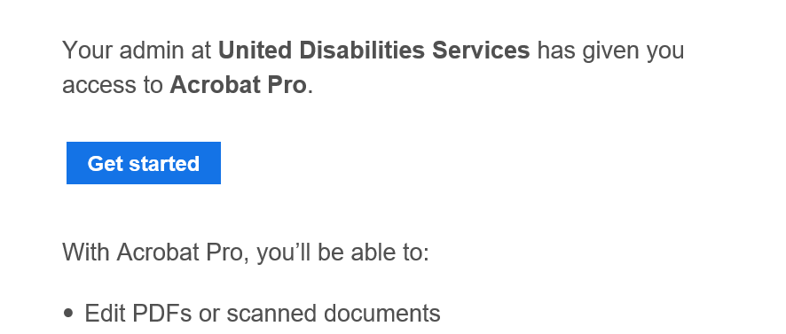

- Click on the blue Get started button in the email. This will start up a web browser and take you to the Adobe “Verify your identity” page.

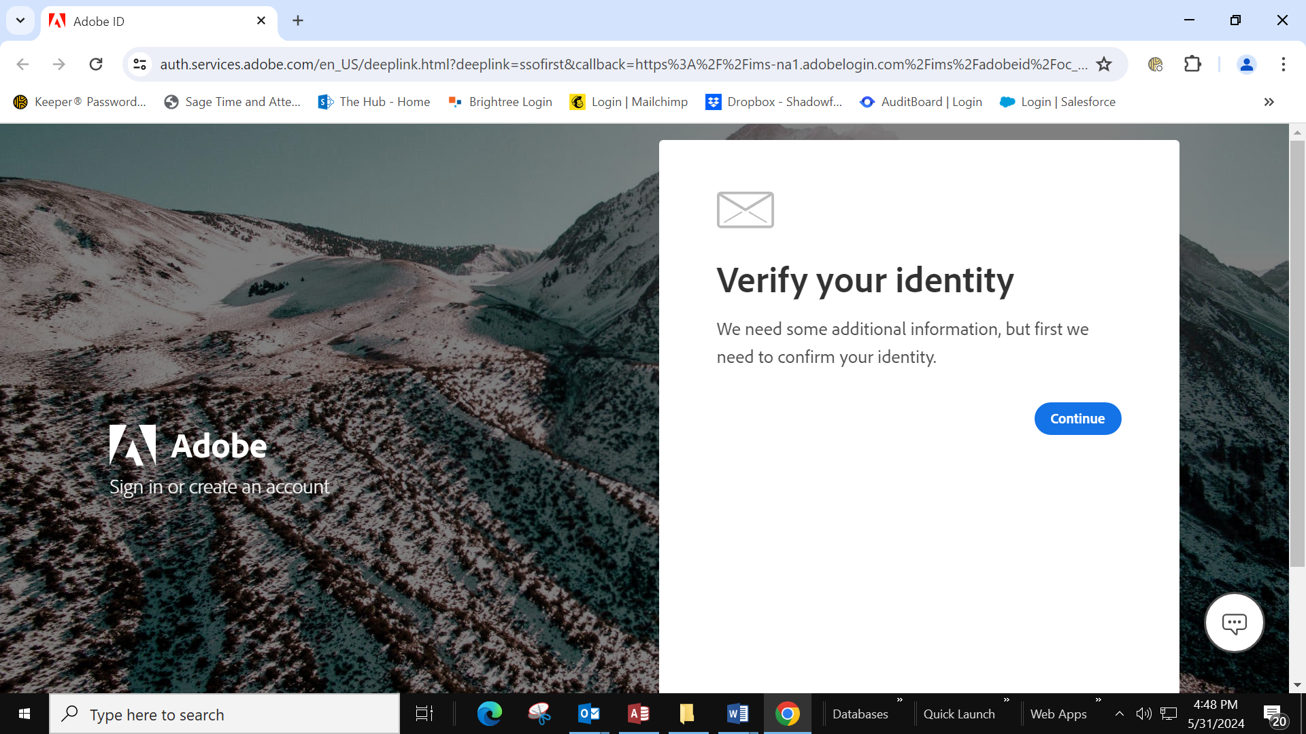

- Click on the blue Continue button.

- An email will be sent to your work email with a verification code. Enter the code in the boxes.

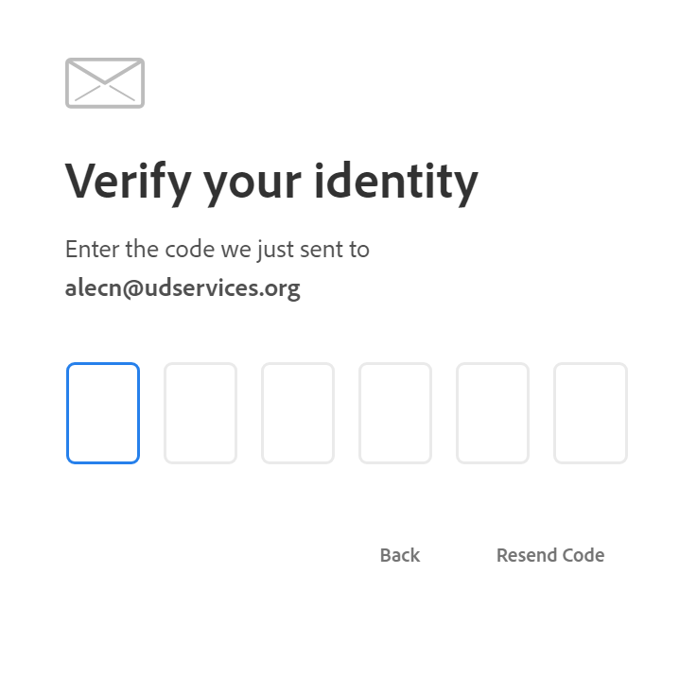

- Enter your first and last name in the fields provided.

- All UDS employees will use the same Acrobat password to create their Acrobat account. The password is 20PDFuds24$. Enter this in the Password field.

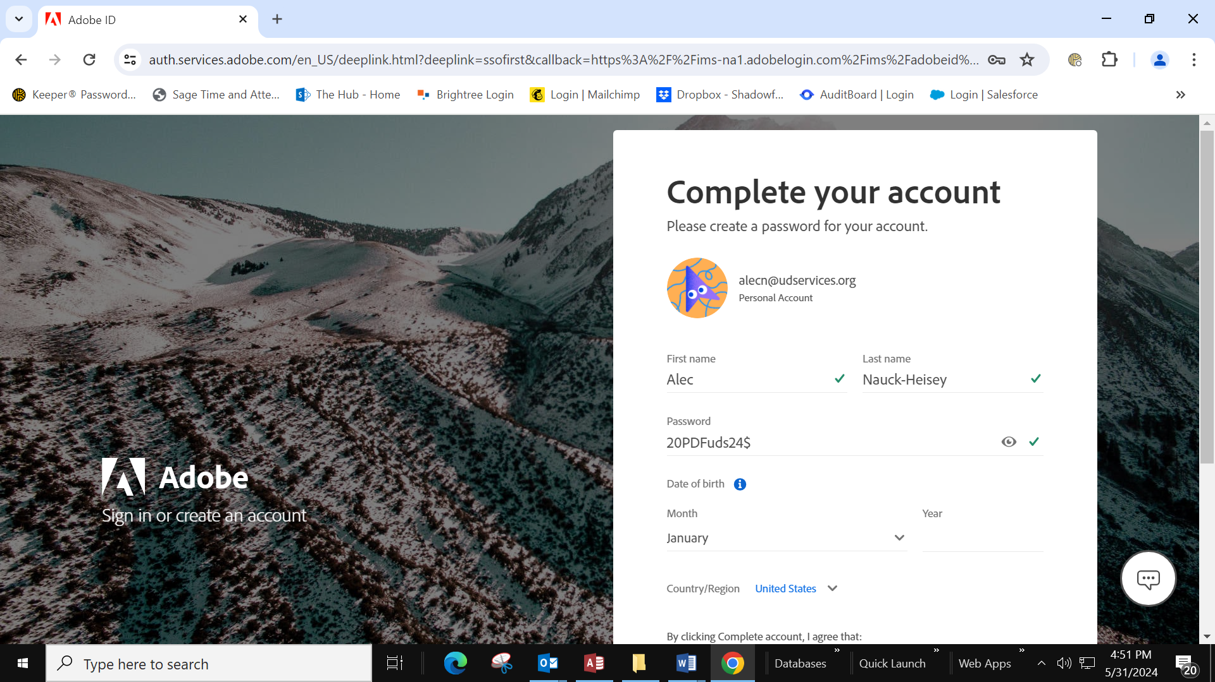

- Enter your birth month and year.

- Click the blue Complete Account button at the bottom.

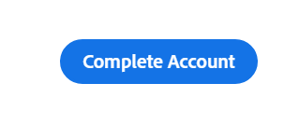

- If you see a message about re-enabling the Acrobat PDFMaker add-in, check the box labeled Do not show this message again, and then click Yes.

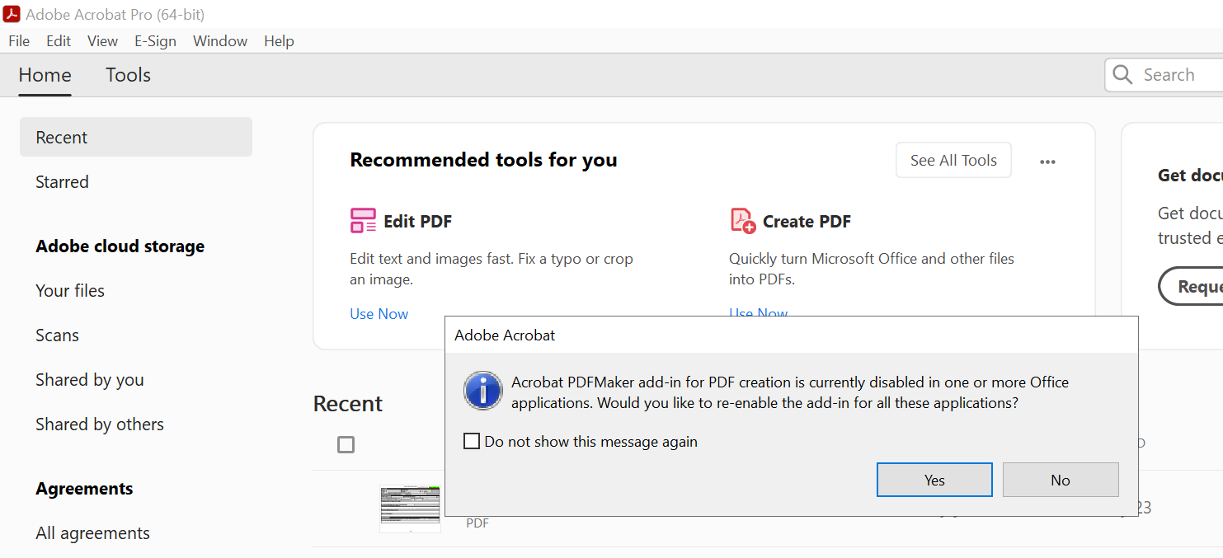

- At this point you can close the browser window.

- Open Acrobat Pro on the terminal server.

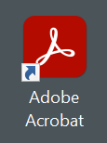

- Click Sign in at the top right corner of the Acrobat Pro window.

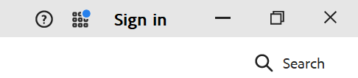

- Sign in with your credentials (work email and company password).

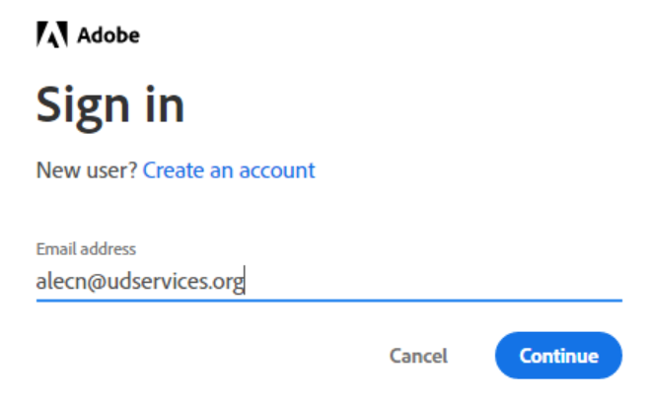

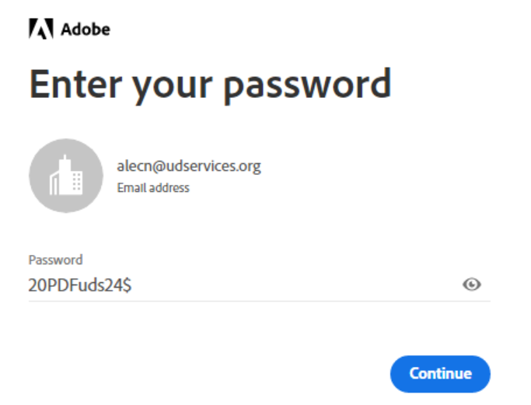

Your Acrobat window should recognize you and show that you’re signed in.

Top left shows welcom and your name Top right corner shows you’re signed in

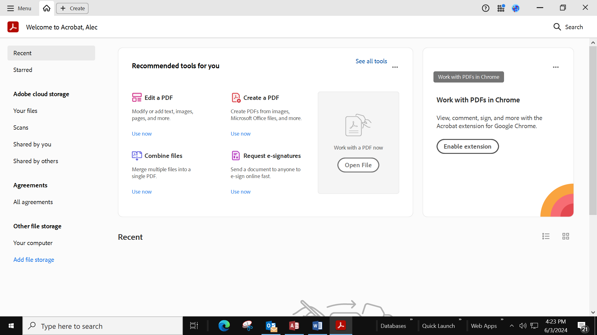

Note: Do not sign out of Acrobat Pro. Once signed in you shouldn’t ever have to sign in again.
Revision History
Name | Date | Reason for Changes | Version
Alec Nauck-Heisey | 6/1/2024 | Initial draft | 1.0 draft 1

